Experiment No: 01

Experiment Name: Introduction to Basic Bash Commands and File System Management.

Theory:
The Bourne Again Shell (Bash) acts as a friendly bridge between you and your computer's operating system. Instead of clicking on icons with a mouse like you do in a standard Graphical User Interface (GUI), Bash lets you control the system by typing plain text commands into a terminal. Linux organizes all of its files and folders in a giant, upside-down tree structure starting from a single top folder called the root (/). When you type commands in Bash, you are either telling the computer where to move inside this tree or asking it to perform a specific action on a file.
Managing files in Bash relies on a few fundamental concepts: navigation, file manipulation, and cleanup. Navigation commands help you move around using absolute paths (the full address starting from the root) or relative paths (shortcuts based on where you are right now). Creation commands let you quickly make empty files or new folders, while viewing commands let you inspect what is inside a file without opening a heavy program. Finally, deletion commands allow you to clean up unwanted items—either safely one by one, or forcefully all at once.
Command Working Principle / Description
whoami Prints the username of the current logged-in user.
pwd Displays the absolute path of the current working directory.
ls Lists the files and subdirectories within the current directory.
cd [path] Changes the working directory to the specified path.
cd .. Moves up one directory level to the parent directory.
cd Resets the active directory back to the user's home directory.
mkdir [folder name] Creates a new directory with the specified name.
touch [file name] Creates a new empty file or updates the timestamp of an existing file.
cat [file name] Reads and outputs the contents of a file directly to the terminal.
nano [file name] Opens a file inside the Nano terminal text editor for editing.
rm [file name] Deletes a specified file.
rm -f [file name] Forcefully deletes a file without asking for confirmation.
rmdir [folder name] Removes a directory (only works if the folder is completely empty).
rm -rf [folder name] Recursively and forcefully deletes a folder along with all its contents.
clear Clears all text from the current terminal screen display.

ScreenShot From Terminal:
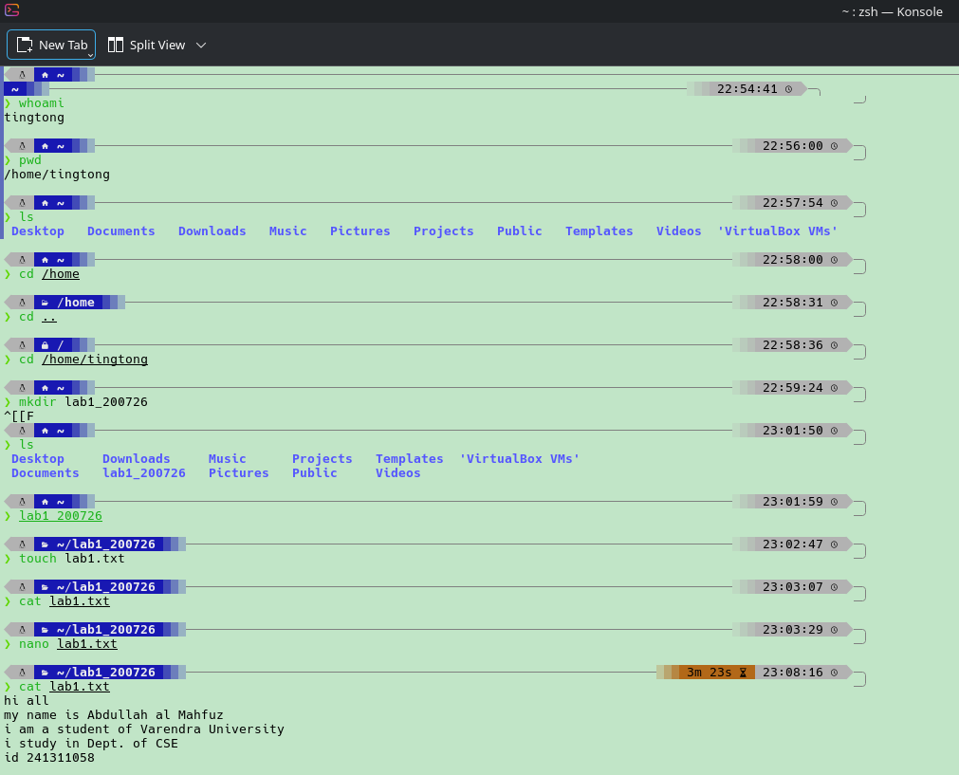
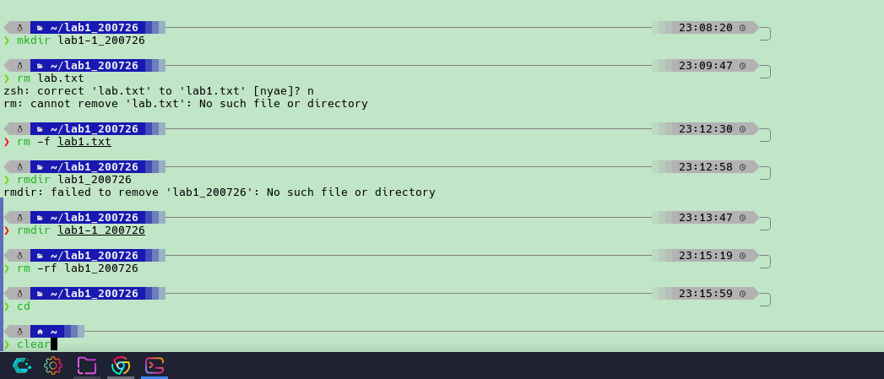

Discussion:
In this experiment, we practiced using basic Linux terminal commands to navigate the file system and manage files and folders. We started by checking who was logged in and finding our exact location in the file tree. We then practiced moving back and forth between parent and child directories, which helped us understand how Linux tracks where you are. We also noticed that typing a folder name by itself causes an error because the terminal expects an actual command, not a path.
Next, we focused on creating, editing, viewing, and deleting files and folders. We created new folders, made a text file, added content using a terminal editor, and printed the content to the screen to confirm our changes were saved. Finally, we tested different ways to delete items. We observed that basic folder deletion commands only work on empty folders as a safety feature, whereas forced recursive deletion commands bypass these protections to remove folders and everything inside them instantly.

